

**North South University**

**Spring – 2023**

**Date of submission: October 25, 2023**

**Prepared by:**

Shah Omar Wasif **– 2012799630**

Turjo Roy **– 2031029630**

Riazur Rahman Shafin **– 1912135030**

Wasif Mohammad khan **– 1831566630**

Ayesha Momtaz Maliha **– 2012640030**

**FIN 444: International Financial Management**

Section-09

**Group Report:**

**Assigned To:**

**Dr. Tanvir Nabi Khan [TNK]**

Assistant Professor of Finance, Department of Accounting & Finance

**North South University**

Contents

Part-I 1

Introduction 1

Chosen Currencies and The Reason for Investing in These Currencies 1

Investment Strategy 3

Observation 6

Conclusion 8

Part-II 9

# Part-I

# Introduction

When trading foreign currencies, the exchange rate is the most important consideration. Even a rookie trader may profit from the foreign currency market.

We're a $50 million currency dealer situated in the US. We bought Euros, British Pounds, Canadian Dollars, Swiss Francs, Singaporean Dollars, and Indian Rupee to diversify our risk. Each country has its own currency. These currencies were picked at random because they have the maximum market liquidity. For fecund currencies, the holding period was 30 days, but loss-producing currencies were transferred quickly to limit risks. As we waited, market forces caused prices to change sporadically, and we did nothing to fix the problem.

Bid (buy) and ask (sell) prices are currency exchange rates. The bid price is the rate at which a bank will purchase a currency, while the asking price is the rate it will sell. As small-scale investors, we bought at ask and sold at the bid or converted back—a total amount of $50,000,000.

# ****Chosen Currencies and The Reason for Investing in These Currencies****

As a US-based currency trader, we will show our report of 30 days of currency trading in 6 different currencies. The Eight currencies we have selected are Euros, British Pounds, Canadian Dollars, Swiss Francs, Singaporean Dollars, and Indian Rupee. In this report, we will evaluate the currency trade of these currencies.

**Euro (€)**

After the US dollar, the Euro is the second most popular currency. The global foreign exchange market has demanded it since the creation of the European Union and the Euro. The euro sign (€) is the currency sign used for the Euro. It is used by 19 member countries of the European Economic and Monetary Union, such as Austria, Italy, France, Germany, Estonia, Lithuania, Belgium, Cyprus, Luxembourg, Finland, Greece, Slovakia, Latvia, Malta, Ireland, the Netherlands, Portugal, Slovenia, and Spain.

**British pound (£)**

The British pound is the third most widely used currency, after the US dollar and the Euro. One

of the most active trading currencies worldwide is the British pound. Approximately 13% of

daily trading volume on foreign exchange markets is made up of the British pound. The GBP

represents the United Kingdom's economy, which consists of England, Scotland, Northern

Ireland and Wales. The UK ranks sixth in terms of GDP and ninth in terms of purchasing power

parity with GBP.

**Canadian Dollar(C$)**

CAD, nicknamed the "loonie," is the currency symbol of the Canadian Dollar. CAD is considered to be a benchmark currency, meaning that many Central banks across the globe keep the Canadian dollar as the reserve currency. Global commodity prices heavily influence it. Because of its remarkable rating in the worldwide currency, investing in Canadian Dollars is highly advised. They are the world's sixth most valuable currency. According to market analysts, their unemployment rate is expected to be around 7.72 percent in 2022, which is a positive indicator. Furthermore, they have an excellent GDP growth rate of 7.3 percent in 2022, placing them ninth in the global GDP rankings.

Canada has had high inflation rates for a long time. Still, tighter fiscal policy and a better current account balance have resulted in fewer budget deficits, lower inflation, and lower inflation rates.

**Swiss Franc (CHF)**

Switzerland is a politically stable and economically developed country with a low unemployment rate and a strong currency. The Swiss franc is considered to be a safe-haven currency, meaning that investors often flock to it during times of market turmoil. The Swiss franc is also used to buy gold, which makes it an excellent way to invest in the precious metal.

**Singapore Dollar (SGD)**

Singapore is a politically stable and economically developed country with a low unemployment rate and a strong currency. The Monetary Authority of Singapore (MAS) is committed to maintaining price stability, which helps to support the value of the Singapore dollar. The Singapore dollar is widely used in international trade and finance, which makes it a liquid and stable currency.

**Indian Rupee (INR):**

India is the world's fastest-growing major economy. India has a young and growing population, which is expected to boost economic growth in the coming years. The Indian government is investing heavily in infrastructure and other development projects.

# Investment Strategy

As a US-based currency trader with a purse worth 10 million USD, the initial value of the portfolio is $50,000,000. The objective of this investment strategy is to capitalize on expected currency movements against the USD over a 35-day investment window. The strategy will be implemented as follows:

**Portfolio Formation**

On the starting date, which is 18th August, 2023, convert $50,000,000 into six different foreign currencies based on their current exchange rates. The allocation of funds into each currency will be based on the trader's expectations of currency appreciation within the 30-day investment

|  |  |  |  |  |  |
| --- | --- | --- | --- | --- | --- |
| Currency | Bid | Ask | Investment (%) | Investment (USD) | Investment in Foreign Currency |
| CAD | 1.35292 | 1.35313 | 30% | $ 15,000,000.00 | 20,296,950 |
| EURO | 0.91941 | 0.91955 | 5% | $ 2,500,000.00 | 2,298,875 |
| BRL | 4.9823 | 4.9857 | 30% | $ 15,000,000.00 | 74,785,500 |
| AUD | 1.5608 | 1.5611 | 20% | $ 10,000,000.00 | 15,611,000 |
| SGD | 1.35944 | 1.35944 | 5% | $ 2,500,000.00 | 3,398,600 |
| INR | 83.1122 | 83.1229 | 10% | $ 5,000,000.00 | 415,614,500 |
|  |  |  | Total | $ 50,000,000.00 |  |

window.

**Monitoring and Adjustment**

Regularly monitor the spot exchange rates of the chosen currencies throughout the 35-day period. If a currency is strengthening against the USD, consider retaining it in the portfolio. If any currency is underperforming or depreciating against the USD, evaluate the expected future trends. If there is no expectation of recovery within the investment window, consider exchanging it for a different foreign currency that is expected to appreciate.

**Hold Period**

Hold the currencies in the portfolio for the entire 35-day period, with the investment window ending on 22nd September, 2023.

**Currency Conversion**

On the 22nd of September, 2023, convert the portfolio, which now consists of the six foreign currencies, back into the home currency (USD) using the exchange rates prevailing on that day.

**Calculate Holding Period Return**

Calculate the holding period return for each currency in the portfolio. The holding period return is a measure of the profit or loss from the currency investments over the 35-day period.

|  |  |  |  |  |  |
| --- | --- | --- | --- | --- | --- |
| Currency | Bid | Ask | Investment (%) | Investment in Foreign Currency | Final Value of the Investment (USD) |
| CAD | 1.34875 | 1.34896 | 30% | 20,296,950 | $ 15,048,711.77 |
| EURO | 0.93884 | 0.93898 | 5% | 2,298,875 | $ 2,448,633.42 |
| BRL | 4.9019 | 4.9054 | 30% | 74,785,500 | $ 15,256,431.18 |
| AUD | 1.559 | 1.5593 | 20% | 15,611,000 | $ 10,013,470.17 |
| SGD | 1.36727 | 1.36754 | 5% | 3,398,600 | $ 2,485,683.15 |
| INR | 83.1084 | 83.1207 | 10% | 415,614,500 | $ 5,000,872.35 |
|  |  |  |  | Total | $ 50,253,802.05 |

Holding Period Return = $\frac{\$50,253,802-\$50,000,000}{\$50,000,000}$

= 0.5076%

**Profit Assessment**

After converting the foreign currencies back into USD, assess whether there are any speculative profits. These profits will be calculated by considering the difference in the portfolio's value between the start date (18th August, 2023) and the end date (22nd September, 2023), accounting for exchange rate movements.

This investment strategy aims to leverage market expectations and exchange rate movements to generate profits within a 35-day period. It requires careful analysis of currency trends and prompt adjustments to the portfolio based on performance. The ultimate goal is to maximize returns and take advantage of favorable currency movements.

Throughout the holding period the portfolio has made $253,802 with $50,000,000 investment. Which indicates we made e 0.5076% profit in the following 35 days.

# Observation

Numerous macroeconomic factors typically have an impact on investing in foreign currencies. Before investing in our chosen currency, we recognized a tendency toward US appreciation against many other foreign countries. We had a significant probability that our return was set to plummet. A typical idea of investing in forex is to invest in those currencies where the currency is more likely to appreciate than their home currency. This could weaken the home currency, but investment returns from investments give investors optimum utility. Though the prior dollar appreciated against these currencies, the bid and ask prices we found after one month were favorable against the USD and appreciated from their earlier values. Luckily, the foreign currencies we invested in rallied back and strengthened against the USD on September 22, which benefited us. However, the adjustments in the ask and bid were less significant at the end of the period than the graph below suggests. Any speculative activity, such as a derivative or option, would have given us more than $25,380.20 on the whole $50,000,000 investment in multiple currencies. But regardless of this great uncertainty and volatility, our holding period rose by just 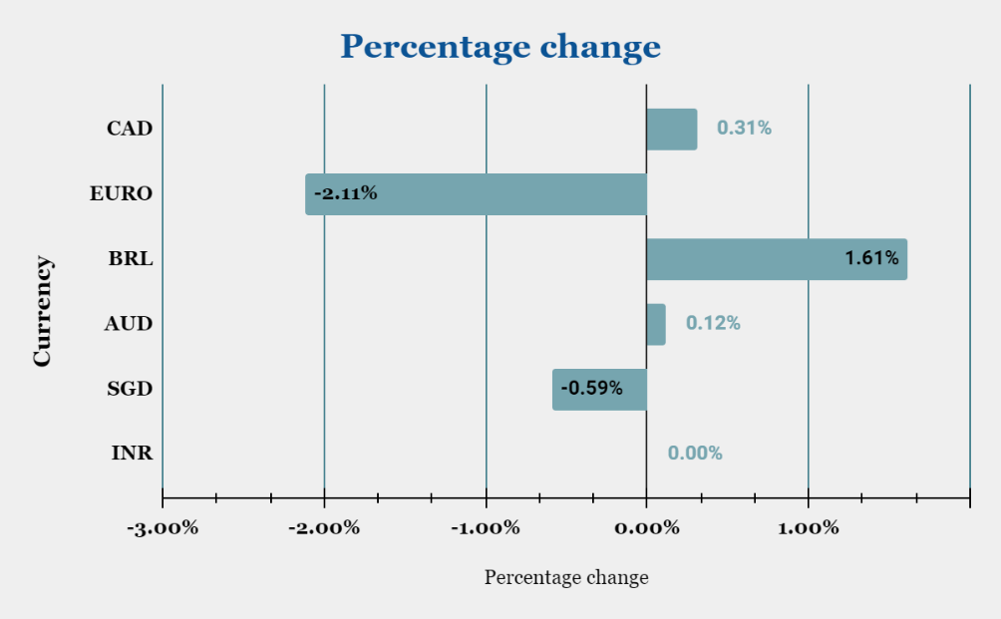1% and wasn’t in red after the end of the holding period.

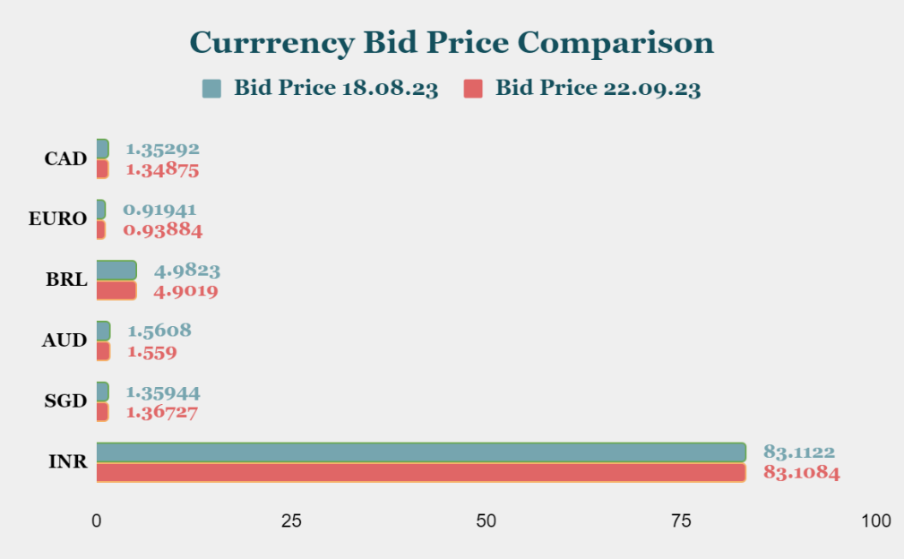

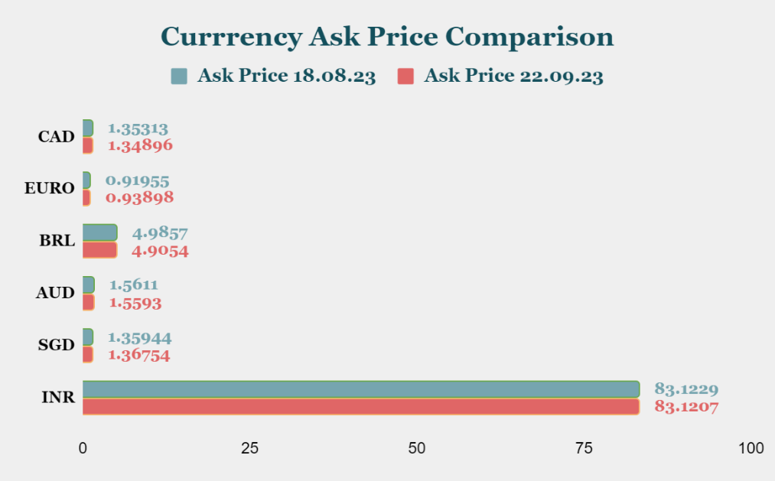

# 

# Conclusion

We tracked changes in the exchange rate over the course of 35 days. Some currencies lost value when compared to the USD. The performance of the currencies EURO, SGD, and INR fell short of our predictions. We did everything we could to maximize profit. After 35 days of holding, we had a positive return of 0.5070% at the end of the period.

# Part-II

**Do you think BDT performed well in the market compared to currencies such as PKR and INR?**

|  |  |  |  |
| --- | --- | --- | --- |
| Year (23 Oct) | PKR/BDT | Percentage change | Changes in 5 years |
| 2019 | 1.8043 | 16.45% | 38.24% |
| 2020 | 1.8763 | 3.99% |  |
| 2021 | 1.9904 | 6.08% |  |
| 2022 | 2.135 | 7.26% |  |
| 2023 | 2.4942 | 16.82% |  |

In the following 5year data table (from 2019-2023; Date: OCT 23) we can see that Bangladesh’s currency BDT has been appreciated against Pakistani currency PKR during this 5-year period. BDT hugely appreciated against PKR during the year 2019 and 2023 which is about 16.45% and 16.82%. From 2019 to 2023 BDT appreciated about 38.24% against PKR.

|  |  |  |  |
| --- | --- | --- | --- |
| Year (23 Oct) | INR/BDT | Percentage change | Changes in 5 years |
| 2019 | 0.8182 | -4.57% | -8.80% |
| 2020 | 0.8423 | 2.95% |  |
| 2021 | 0.8578 | 1.84% |  |
| 2022 | 0.7973 | -7.05% |  |
| 2023 | 0.7462 | -6.41% |  |

On the other hand, in terms of BDT against India’s currency INR we can see that it has BDT has depreciated in the year 2019,2022 and 2023 and it has appreciated in the year 2020 and 2021. Furthermore, in the recent years BDT is depreciating heavily against INR being 7.05% in the year 2022 is highest depreciation seen in the following 5 years. On the contrary, BDT appreciated 2.95% in the year 2020 which is being the highest appreciation in the previous 5 years. For a 5-year overview, BDT has depreciated about 8.8% against INR.

In conclusion, we can say that BDT performed very well in the market compared to PKR (BDT appreciated 38.24%) in the following 5 years on the contrary it has performed worse against INR that it depreciated about 8.8% within the 5-year period.

# References

1. Onada. (n.d.). *OANDA CURRENCY CONVERTER*. Retrieved from Onada: https://www.oanda.com/currency-converter/en/